Northern Ireland Schools Football Association (NISFA) 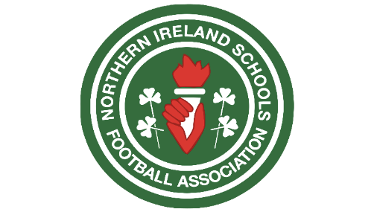

Role
The Northern Ireland Schools Football Association wishes to appoint a suitably qualified person to the role of Strategy and Governance Development Manager.

Job Description
The Northern Ireland Schools Football Association (NISFA) is recognised as the body responsible for the development of competitive schools’ football across Northern Ireland. Supported by revenue generated via sponsorship, partnerships, and competitions, NISFA aims to develop football opportunities for boys and girls through competitions, representative football, development initiatives, and participation programmes.
The NISFA employee will drive forward the organisation’s mission and values by working closely with schools, strengthening existing membership, attracting new schools, increasing pupil participation, and implementing the IFA Youth Football Framework across the schools’ game.
The employee will develop strategic growth through sponsorship, fundraising, digital development and marketing, while overseeing and managing NISFA’s four social media platforms through the creation of engaging graphics, digital content, and promotional campaigns. The role will ensure NISFA develops sustainable income streams, increases visibility and engagement, delivers a modern communications strategy, and supports the continued growth of schools’ football across Northern Ireland.
Key Responsibilities & Strategic Deliverables
Strategic Leadership & Governance
- Implement strategic vision in alignment with and reporting directly to the NISFA Board of Directors.
- Develop, draft, and implement robust organisational policies, including safeguarding, operational compliance, and governance frameworks.
- Lead the implementation and integration of the IFA Youth Football Framework across schools’ football structures and programmes.

School System Engagement, SEN & Mentorship
- Leverage an in-depth understanding of the Northern Ireland school system to navigate education structures, build stakeholder relationships, and align with school calendars.
- Design and execute tailored initiatives for pupils with Special Educational Needs (SEN) to ensure fully inclusive access to football pathways.
- Develop student mentorship frameworks to support pupil development, leadership, and personal growth through sport.
- Work with schools and stakeholders to identify barriers to participation and create inclusive pathways.

External Partnerships & Income Generation
- Secure and maximize external funding opportunities through grants, commercial partnerships, and sponsorship initiatives.
- Demonstrate a proven track record in building and managing formal relationships with external partners, including universities, corporate sponsors, and governing bodies.
- Identify and deliver innovative fundraising opportunities to support long-term sustainability.
Marketing, Digital Media & Graphic Design
- Manage, control, and create content for four key social media platforms, ensuring consistent branding, audience growth, and dynamic engagement.
- Hands-on design and delivery of dynamic graphic design assets, promotional materials, video content, and digital campaigns.
- Lead the design, launch, and ongoing management of the NISFA website and digital platform to improve communication and member services.
- Develop and execute a comprehensive marketing plan to raise the overall profile of schools football in Northern Ireland.

Working Details
- Reports to: NISFA Board of Directors
- Working Hours: Full-time, 12 months (Monday to Friday, with required evening and weekend flexibility throughout the competitive season)
- Travel Requirements: Frequent travel across Northern Ireland (clean driving license required)
- Salary: £35,000 per annum, with opportunities for additional performance benefits.

Applications should be returned to neil@nisfa.co.uk by Friday 18th September 2026 at 5pm.

